Model-Based Code GenAI

Advisor: Natali Levi
By: Stav Avraham, Omri Spitzer
Keywords: Generative, Artificial Intelligence, OPL, Text-To-Code, Software
Project Number: 26-1-R-7
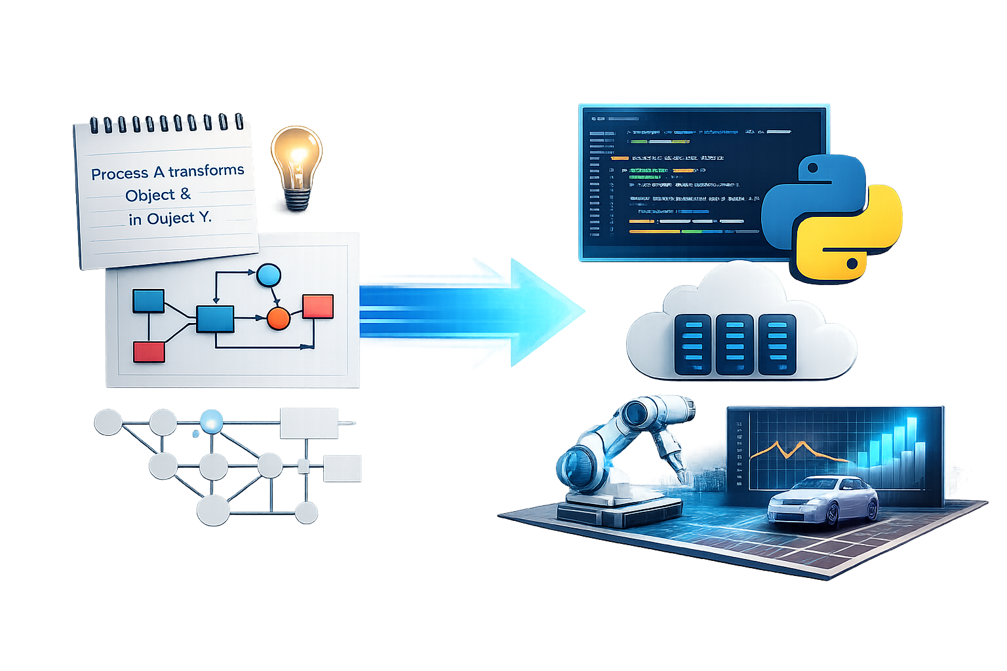

Table of Contents
Abstract
- Introduction ..................................................................................................... 2-3
- Literary Review ............................................................................................... 4-5
- Requirements ..................................................................................................... 6
- Project Solution .............................................................................................. 7-9
- Deployment ................................................................................................. 10-11
- Evaluation ......................................................................................................... 12
- Success Factors ………………………………………………………………….… 13
- Tools & Prompts ......................................................................................... 13-15
- Challenges ........................................................................................................ 15
- References & Appendices ......................................................................... 16-18

Abstract
The development of well-engineered software systems relies on accurately translating client requirements into a structured architecture. While Generative Artificial Intelligence tools are increasingly used to generate software directly from free-text descriptions, such approaches often suffer from ambiguity, incomplete specifications, and misinterpretation of client intent. As a result, code generated solely from natural language instructions may be executable, yet fail to correctly reflect the intended system structure, behavior, and architectural constraints.
In this research, we investigate whether code generated using a formal system modeling logic can improve the quality of AI-generated software. We propose an AI agent pre-trained on Object-Process Language, the textual representation of Object-Process Methodology, and evaluate its ability to generate executable code that aligns to specified client requirements. The generated solutions are compared to manually written code by human programmers, and generated code by LLM agents, using our defined evaluation metrics.
- Introduction
Developing well-engineered software begins with translating the client’s requirements into a well-structured architecture, designed by a software architecture. This initial phase is crucial for aligning the system to the client's demands. System diagrams, such as - UML [16], SysML [17], OPM [15] and more - aim to design the system’s structure and behavior. For our research, we chose OPM as our basis for the system structure.
Prof. Dov Dori mentioned in his article [14] that humans have dual-channel understanding mechanisms, image and textual representations. Based on those mechanisms, combining both representations enhances clear comprehension. OPM represents both the objects in a system and the processes that transform them, enabling the expression of behavioral flows between system entities. By capturing structure and behavior within a single model, OPM exposes the system’s architectural layers and the relationships among them. In this context, OPL serves as the derived textual counterpart of the OPM diagram, providing a clear and consistent natural language description of the same objects and processes.

Generative Artificial Intelligence [4] has become widely used, with many advantages. Clients increasingly attempt to create software by describing their needs to an AI tool and expecting it to generate a complete solution. These AI tools are capable of creating the code, but can often lead to system implementation problems.

Relying solely on free-text instructions has significant limitations. Natural language is ambivalent, and often lacks the level of detail required to fully define a system’s structure and behavior. Although GenAI tools can generate code, they may misinterpret requirements, overlook essential constraints, or fill in missing information with assumptions that do not match the client’s intent.

As a result, the produced software may appear functional but fail to represent the system’s intended architecture or logic. These inconsistencies make it difficult to rely on free-text-driven AI for building executable code that aligns with the client requirements.

RQ1: Does code generated by an AI agent pre-trained on OPL logic, is more consistent with client requirements, compared to code developed manually by human programmers?

RQ2: To what extent do the results generated by the AI agent meet the specified client requirements, while being executable?

In the following chapters, we intend to answer the questions beforehand. Chapter 2 shows our review of related solutions and their drawbacks. Chapter 3 explains our project's functional and non-functional requirements. In Chapter 4, we summarize our solution, while in Chapter 5, we explain the architecture. In Chapters 5 and 6 we explain the agents evaluation metrics and our project’s success factors. Chapter 7 explains the tools and prompts used to achieve the solution, and in Chapter 8 we show our challenges in the making of the agent. In the final Chapter we give references used for the Literature Review.

- Literary Review
Software systems went through a significant evolution over the past decades, growing from small, one-purpose programs into large, complex, and highly connected systems. Modern software development typically follows a multi-stage lifecycle that includes requirement definition, system design, implementation, testing, deployment, and long-term maintenance [1][2]. Therefore, each of these stages demands more time and resources, as to the size of the system programmed. In particular, the gap between meeting client requirements and executable implementations has widened, making it increasingly difficult to ensure correctness, consistency, and traceability throughout the development process [3].
In recent years, generative artificial intelligence (GenAI) [4], and in particular Large Language Models (LLMs), have become increasingly accessible for individual use [5]. Various GenAI agents have demonstrated the ability to process natural-language inputs, model systems, and generate software code [6], thereby enabling partial automation of the system design and implementation stages within the software lifecycle. As a result, employing such agents as instruments for code generation presents a significant advantage in software development, especially by accelerating development processes and reducing manual effort.

ChatGPT [7] is an example of a user-friendly generative AI system that provides high-level capabilities such as natural-language interaction and automated task execution [8]. A key strength of ChatGPT lies in its ability to translate textual user requests into executable code, enabling users to generate software directly from natural-language descriptions [8]. Similar capabilities have been demonstrated in applications using LLMs for software and systems engineering, where natural-language requirements are automatically transformed into models, test scenarios, and implementation code [9]. These approaches support faster prototyping and reduce the gap between high-level user intent and formal software artifacts, particularly in early development phases.
Despite these advantages, the generated responses are insufficient and are not reliable for software development tasks [8]. They may produce outputs that are syntactically correct yet semantically incorrect or misaligned with the original requirements [9]. This phenomenon, commonly referred to as hallucination, becomes particularly problematic in complex or safety-critical systems, where subtle semantic errors can lead to incorrect system behavior. Consequently, these limitations highlight the need for additional validation layers, such as model-based approaches (e.g., OPM), to enforce correctness, consistency, and traceability between requirements, models, and generated implementations.
AI-driven application builders like Base44 [10], allow users to describe an application in natural language and automatically generate full-stack solutions, including UI, backend, and data management. However, Base44 offers no formal guarantees of correctness, consistency, or traceability, relying on unstructured prompts and iterative refinement. While useful for rapid AI-assisted development, it does not support structured, validated transformation from formal requirements (e.g., OPL/OPM) to reliable software.
Another software solution is MAXIM via OPCloud [11][12]. To demonstrate its capabilities, the authors present a ‘Cockpit Display System’ [11], which serves as a realistic example of a complex system, composed of multiple interacting components and layers. When executed using OPCloud [12][13], the model shows the interaction between objects and processes. With inputs to object states, the client can validate system logic early in the design phase, reason about behavior, and demonstrate computability [11], without the assistance of a software architect.
Despite demonstrating executable models, MAXIM does not support automatic code generation [11][12]. Although architects can precisely capture client requirements and validate system behavior at the modeling level, the transition to implementation remains largely manual, which prolongs development and increases the likelihood of production errors [3].
These limitations motivate the adoption of a generative AI–based approach, which seeks to lower the expertise barrier, enabling the direct translation of natural-language requirements into software artifacts, and minimize the manual effort required to bridge the gap between design models and fully executable code. Due to economic constraints, the use of existing code generation agents was not considered in this research. Instead, we developed and fully implemented a dedicated agent specific to the objectives of this study.

- Requirements
Functional requirements:
- The system shall enable code generation.
- The system shall understand the OPL syntax.
- The system shall produce an executable code file.
- The system shall receive OPL as input.
- The system shall evaluate the generated code.
- The system shall have a user interface.
- The system shall fetch and insert data into a database.

Non-functional requirements:
- The interface shall show the progress of the system.
- The interface shall receive one OPL at a time.
- Error messages shall be shown for invalid OPL inputs.
- Detailed logs shall be shown to help developers fix errors.
- The interface shall provide a clear and intuitive graphical user interface (GUI).
- The interface shall allow users to load and save OPL files locally.
- The interface shall include brief explanations for all buttons and options.
- The system shall provide clear internal documentation for all major modules.
- The system shall separate the GUI code from the backend logic.
- The system shall use an AI agent.
- The system shall train the AI agent when in the building phase.

- Project Solution
Environment - User

Input OPL file
Output
Agent - Google ADK
LLM - Gemini
Roles - Instructions
Memory - MongoDB
Critic
Generator
Supervisor
Optimizer
Tools
Code Evaluator
Code Generator
OPL Map Optimizer

Our solution is a generative agent that uses Gemini’s LLM API to map OPL logic into executable code through a structured, multi-step workflow built with Google’s Agent Development Kit (ADK). The agent processes OPL input through defined roles, where each stage contributes to transforming the input into correct and executable code, with iterative refinement based on evaluation feedback. To improve mapping accuracy and reliability, the agent is pre-trained on supervised OPL examples, enabling it to learn consistent relationships between OPL constructs and their corresponding implementations.

In the following pages, we define the agent’s roles as a set of structured instructions, illustrated by diagrams for clarity:
- The Supervisor acts as the central controller, selecting the appropriate role for each step based on the current objective, whether training mapped logic or processing a single OPL input for demonstration. It is the only role that interacts with the user interface and operates under a defined iteration limit despite being able to invoke roles multiple times.
- The Generator is responsible for producing syntactically valid code from a given OPL input and returning the result to the Supervisor, also operating under iteration constraints.
- The Critic evaluates the generated code according to predefined metrics, assessing its correctness and quality.
- The Optimizer uses this evaluation to refine and improve the OPL mapped logic, if possible, before handing control back to the Supervisor, with its execution similarly bound to prevent unregulated iteration.
Supervisor - Instruction
Initial start?
True
False
Handoff to Generator
Training mode?
Get Training OPL from Database
True
Get OPL from User
False
Define which Role to use or None
Handoff to Agent Role
Reply to User and Finish
Is None?
Define cnt_itr = 0
cnt_itr += 1
cnt_itr == max_itr ?
False
Generate Problem
False
True
True
Save Problem in Database

Generator - Instruction
Handoff to Supervisor
Get OPL file
Retrieve OPL Logic Map
Generate Code
Validate Code Syntax and Semantic
Valid code?
True
False
Save to Database
Define ctr_gnr = 0
ctr_gnr += 1
ctr_gnr == max_gnr?
False
True
Generate Problem
Save Problem in Database

Critic - Instruction
Get OPL Map from Database
Valid OPL_Map?
Validate OPL Map
Handoff to Supervisor
False
Get Evaluation Metrics
True
Generate Code Evaluation
Generate Pass Evaluation
Get Pass Metrics
Generate Problem
Save Problem in Database

Optimizer - Instruction
Handoff to Supervisor
Code Passed?
True
Get OPL Pass
Get OPL Evaluation
Mark code as ‘Passed’ in Database
False
Get OPL Optimization
Optimize OPL Map
Define cnt_opt = 0
cnt_opt == max_opt?
False
Valid new OPL Map?
cnt_opt += 1
False
True
True
Generate Problem
Save Problem in Database

- Deployment
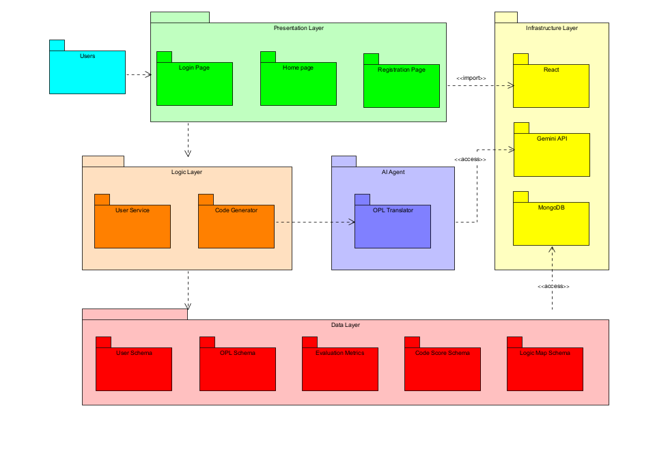
Figure 3 : Project Architecture - The project architecture integrates a multi-layer system where users interact through a presentation layer connected to logic, AI agent, and data layers supported by React, RL training, Gemini API, and MongoDB infrastructure.

Figure 3 presents the architecture of our project, which consists of four main layers:
- Presentation Layer – This layer represents the user interface of the web application. It is responsible for displaying data retrieved from the Logic Layer and providing users with interactive functionality.
- Logic Layer – This intermediate layer handles the core processing of the system. It manages communication between the user interface, the database, and the AI agent.
- Data Layer – This layer manages storage of system data for future retrieval and analysis. We chose MongoDB as our database due to its flexibility with unstructured data.
- Infrastructure Layer – This layer consists of external services and supporting technologies required for system operation.

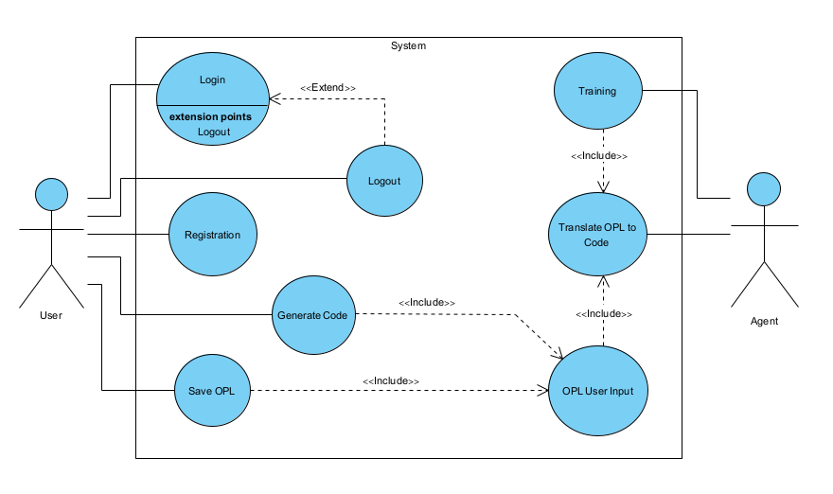
Figure 4 : Project Functionality - overall functions that can be done by the user and proposed agent.

Figure 4 shows the overall functional flow of the system, alongside the user’s available interactions. When a user requests code to be generated, an OPL file must first be provided as input. This input is then processed and translated into executable code by the AI agent. It is important to note that code generation is only possible once the agent has completed the required training phase, which is conducted iterations of generating code through pre-defined datasets.

- Evaluation

Metric | Explanation | Weight | Method
Executability | Check the generated code’s executability | 0.4 | Judge0 Extension
Graph Coverage | Check OPL convergence through graph similarity. | 0.4 | Constructing a graph using the OPL input, and a graph for the generated code. Evaluating similarity between edges and nodes
CodeBLEU | Check Syntical and Samantical errors | 0.2 | CodeBLEU Extension
The evaluation metrics presented in the table are designed to assess the quality of code generated by our proposed agent. Our primary focus is on the convergence between the OPL and the generated code snippet, as this reflects how similar the generated code is to the formal specifications defined by the OPL. We presume that the weighted metrics are beneficial to the agent’s training phase, and when we shall create the agent, we will reflect on these weights for better results.
In addition, we emphasize practical usability: the generated code must be fully executable. For this reason, the “Executability” and “Graph Coverage” metrics are assigned greater importance than “CodeBLEU”, as they better capture correctness, completeness, and alignment with the intended logic, rather than surface-level similarity to reference implementations.
Specifically, both “Executability” and “Graph Coverage” are weighted at 0.4 each, as they directly measure whether the solution works in practice and whether it faithfully represents the modeled system behavior and structure. In contrast, “CodeBLEU” is assigned a lower weight of 0.2, since it primarily evaluates syntactic and semantic similarity, which, while useful, does not guarantee functional correctness or adherence to the underlying formal model.

- Success Factors
To answer RQ1, we compare code generated by the OPL-pretrained AI agent with code manually written by human programmers. Both outputs are evaluated using the same metric set. The results are then compared to determine which approach is more consistent with the specified client requirements.

To answer RQ2, we evaluate whether the generated code executes successfully and correctly implements the specified requirements. This is measured by achieving higher evaluation scores compared to an LLM-based agent without prior training. In addition, we will conduct an experiment in which students from different academic institutions will provide OPM descriptions, from which will be translated to OPL and the system will generate code. The students will then evaluate the generated outputs using a questionnaire [Appendix] based on the System Usability Scale (SUS) to assess the usability and effectiveness of the system.

We also aim to conclude that the agent is successful if it consistently generates solutions that achieve an evaluation score above 90. This threshold was selected as a benchmark for high-quality performance, reflecting a strong alignment between the generated code and the specified requirements. While an absolute (perfect) score would represent complete alignment, we do not consider it a realistic expectation in practice, given the inherent complexity and variability of software generation tasks.

- Tools & Prompts
Code Generator Tool:
from transformers import AutoTokenizer, AutoModelForCausalLM
import torch

def Code_Generator_Tool(opl:dict):
"""
This tool is used to generate code.
"""
model_name="bigcode/starcoder"
device = "cuda" if torch.cuda.is_available() else "cpu"
tokenizer = AutoTokenizer.from_pretrained(model_name)
model = AutoModelForCausalLM.from_pretrained(
model_name,
torch_dtype=torch.float16 if device == "cuda" else torch.float32,
device_map="auto"
)

prompt = "\n".join(opl.values())
inputs = tokenizer(prompt, return_tensors="pt").to(device)

outputs = model.generate(
**inputs,
max_new_tokens=300,
temperature=0.2,
do_sample=True,
pad_token_id=tokenizer.eos_token_id
)

result = tokenizer.decode(outputs[0], skip_special_tokens=True)
return result[len(prompt):]

OPL Map Optimizer Tool:
from google import genai

def OPL_Map_Optimizer_Tool(opl_map:dict, constraints:dict, metrics:dict, api_key: str):
"""
This tool is used to optimize an OPL map.
"""
client = genai.Client(api_key=api_key)

prompt = f"""
You are an expert compiler optimizer for an Object Processing Language (OPL).

Your task:
Rewrite and optimize the given OPL MAP.

You MUST:
- Improve logic correctness
- Improve execution order
- Remove redundancy
- Add missing necessary steps
- Respect constraints
- Optimize according to metrics
---
### INPUT OPL MAP:
{"\n".join(opl_map.values())}
---

### CONSTRAINTS:
{"\n".join(constraints.values())}
---
### EVALUATION METRICS:
{"\n".join(metrics.values())}
---
### OUTPUT RULES:
- Return ONLY a valid optimized OPL map (same JSON structure style)
- Do NOT explain
- Do NOT add commentary
- Keep schema consistent
"""

response = client.models.generate_content(
model="gemini-1.5-pro",
contents=prompt
)

return response.text.split("\n")[1:]

- Challenges
- Data availability - A potential challenge that could be is lack of sufficient datasets. Without enough high-quality data, the accuracy and reliability of the results may be significantly compromised, which could undermine the effectiveness of the solution.
- Technical expertise - Another limitation is our current level of technological knowledge. Implementing this solution may require specialized skills that we do not possess, making it difficult to develop and maintain the system properly.
- Technological environment - The project may also demand a technological infrastructure that is beyond our reach. For instance, running the system might require high-performance servers or cloud resources that are not accessible due to budget constraints or hardware limitations.
- Evaluation metrics - The defined evaluation metrics may tune for the worse, and lead to un-real results.

- References & Appendices

[1] Kute, S. S., & Thorat, S. D. (2014). A review on various software development life cycle (SDLC) models. International Journal of Research in Computer and Communication Technology, 3(7), 776–781.

[2] Hossain, M. I. (2023). Software development life cycle (SDLC) methodologies for information systems project management. International Journal For Multidisciplinary Research, 5(5). https://doi.org/10.36948/ijfmr.2023.v05i05.6223

[3] Bjarnason, E., Runeson, P., Borg, M., Unterkalmsteiner, M., Engström, E., Regnell, B., Sabaliauskaite, G., Loconsole, A., Gorschek, T., & Feldt, R. (2023). Challenges and practices in aligning requirements with verification and validation: A case study of six companies. arXiv. https://doi.org/10.48550/arXiv.2307.12489

[4] Zhijun Zhang, Jian Zhang, Xiaodong Zhang, Weijian Mai (2025). A comprehensive overview of Generative AI (GAI): Technologies, applications, and challenges. Neurocomputing, Volume 632, 2025, 129645, ISSN 0925-2312. https://doi.org/10.1016/j.neucom.2025.129645

[5] Chatterji, A., Cunningham, T., Deming, D. J., Hitzig, Z., Ong, C., Yan Shan, C., & Wadman, K. (2025). How people use ChatGPT (NBER Working Paper No. 34255). Cambridge, MA: National Bureau of Economic Research.

[6] Calegario, F., Burégio, V., Erivaldo, F., Andrade, D. M. C., Felix, K., Barbosa, N., Lucena, P. L. S., & França, C. (2023). Exploring the intersection of generative AI and software development [White paper]. arXiv. https://doi.org/10.48550/arXiv.2312.14262

[7] OpenAI. (n.d.). ChatGPT. https://chatgpt.com/

[8] Rice, S., Winter, S. R., & Rice, C. (2023). The advantages and limitations of using ChatGPT to enhance technological research. SSRN Electronic Journal. https://doi.org/10.2139/ssrn.4416080

[9] Jin, H., Huang, L., Cai, H., Yan, J., Li, B., & Chen, H. (2024). From LLMs to LLM-based agents for software engineering: A survey of current, challenges and future. arXiv. https://doi.org/10.48550/arXiv.2408.02479
[10] Wix. (n.d). Base44, https://base44.com/

[11] Levi-Soskin, N., Marwedel, S., Jbara, A., & Dori, D. (2024). Enhancing conceptual models with computational capabilities: A methodical approach to executable integrative modeling. Systems Engineering, 27, 759–770. https://doi.org/10.1002/sys.21750

[12] Dori, D., Kohen, H., Jbara, A., Wengrowicz, N., Lavi, R., Levi-Soskin, N., Bernstein, K., & Shani, U. (2020). OPCloud: An OPM integrated conceptual-executable modeling environment for industry 4.0. In Systems Engineering in the Fourth Industrial Revolution: Big Data, Novel Technologies, and Modern Systems Engineering (pp. 243–271). Wiley. https://doi.org/10.1002/9781119513957.ch11

[13] OPCloud. (n.d.). OPCloud. https://www.opcloud.tech/

[14] Dori, D. (2008). Words from pictures for dual-channel processing. COMMUNICATIONS OF THE ACM. https://dovdori.technion.ac.il/wp-content/uploads/2022/02/WordsFromPicturesForDualChannelProcessing.pdf
[15] Dori, D. (2002). Object-Process Methodology: A holistic systems paradigm. Springer. https://doi.org/10.1007/978-3-642-56209-9
[16] Object Management Group. (n.d.). Unified Modeling Language (UML). https://www.uml.org/
[17] Balmelli, L. (2007). An overview of the systems modeling language for products and systems development. Journal of Object Technology, 6(6), 149–177. https://doi.org/10.5381/jot.2007.6.6.a5

Appendix : Code review questionnaire (John Brooke - 1986)
- I think that I would like to use this system frequently.
- I found the system unnecessarily complex.
- I thought the system was easy to use.
- I think that I would need the support of a technical person to be able to use this system.
- I found the various functions in this system were well integrated.
- I thought there was too much inconsistency in this system.
- I would imagine that most people would learn to use this system very quickly.
- I found the system very cumbersome to use.
- I felt very confident using the system.
- I needed to learn a lot of things before I could get going with this system.
Participants rate the following 10 statements on a 5-point Likert scale:
1 = Strongly disagree, 2 = Disagree, 3 = Neutral, 4 = Agree, 5 = Strongly agree
Scoring:
- Odd-numbered questions (1,3,5,7,9): score = response - 1
- Even-numbered questions (2,4,6,8,10): score = 5 - response
- After summing all question scores: final SUS = scores * 2.5

